Cymraeg
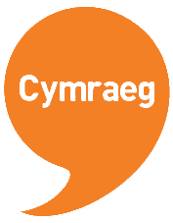
Listen out on Seesaw/Twitter to hear our whole school ‘Brawddegau o’r Wythnos’ (sentence of the week)

Beth hoffet i…?
(Bear-th hoff-et ee??)
What would you like?

Hoffwn i…
(Hoff-un ee…)
I would like…
E.g Beth hoffet ti wneud?
(What would you like to do?)

Hoffwn i coginio cacen!
(I would like to cook/bake cakes!)

E.g Beth hoffet ti fwyta?
(What would you like to eat?)

Hoffwn i fwyta tost!
(I would like to eat toast)

Have a go at extending your answers if you can!
a = and
achos = because
ond = but
hefyd = also

Here is the CSC Challenge for this week too! We can’t wait to see your creations on Seesaw and/or Twitter! Use the video option on Seesaw to record your character speaking Cymraeg!



