Collaborative Learning Activity
Hwb Heroes Assemble!

It has been a while since you worked alongside a partner or in a group!
Your task is to create a presentation sharing how you keep positive during this time. This is for our 'Hwb Heroes Assemble’ challenge.
You can find out more about it on our Class Page or Seesaw.

- First of all, you need to decide who you want to collaborate with. You could work in a pair or you can make a larger group. If you really would prefer to do this activity independently, that is fine.

- Then discuss together how you want to present your ideas. You could do this over the phone (ask an adult’s permission for this) or communicate through your Hwb email.

- Next, decide how you want to present your work. You could use PowerPoint/ Sway/Word or you may want to make a video using Adobe Spark.

- One of you will need to go into your Hwb account and open one of these documents then save it to your One Drive. You do this by opening Office 365 on your Hwb log in page.

- Then you will need to choose Word, PowerPoint or Sway
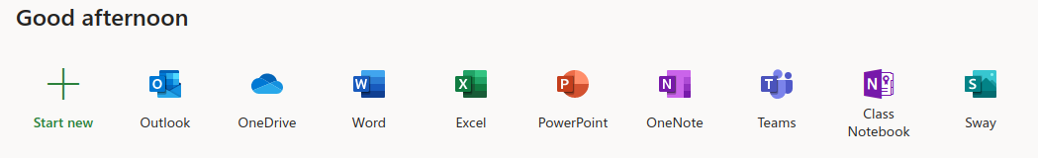

- Create a document and give it a title (eg. 'Hwb Heroes’ + your names) You will need to save it in your One Drive.
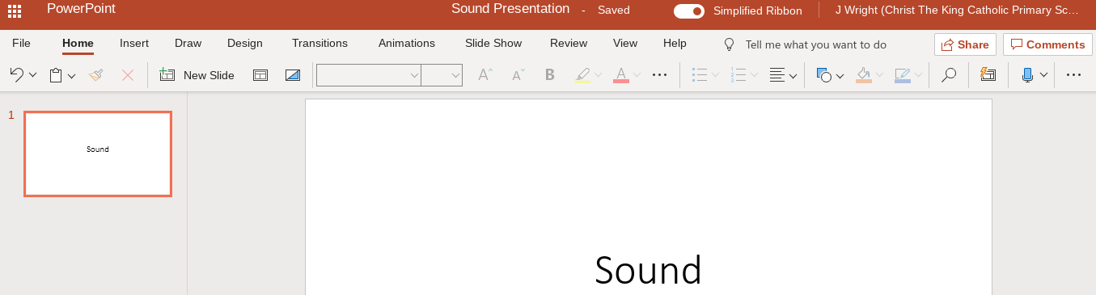

- Once you have made the document, you will need to share it with the other members of your group. Do this by clicking on the ‘Share’ icon on the top right of the screen.

- You will need to ask for the email addresses of the other members of your group and enter them into this box when you have opened it. Please also include my username (WelshB1@hwbmail.net) so I can see what you have produced.
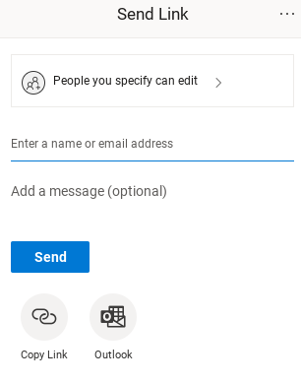
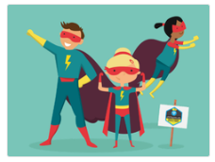
Pob lwc pawb!

