Hwb Heroes Assemble!
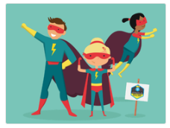
Wales Education Minister, Kirsty Williams, is asking all the children of Wales to spread POSITIVE and ENTERTAINING MESSAGES online to the people who are currently self-isolating due to the Covid-19 lockdown.
We would like you to get creative and send us your original artwork such as:
- drawings
- poems
- stories
- messages
- songs
- dances
- animations.
They will be published on Hwb so that everyone can see all your messages of HOPE, LOVE and SUPPORT and importantly, show older and vulnerable people HOW MUCH WE CARE!
IMPORTANT:
Only upload messages that you have made yourself (not copied from anyone else).
You must ask the grown-up who you live with if it is ok to upload your message for everyone to see online.

Here’s how you can send your message:
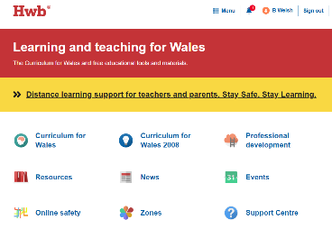
1) Login to Hwb and go to ‘News’
2) Use the entry form to upload your files (follow the link when you log into Hwb)
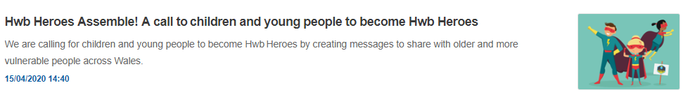
Messages will be moderated and then published on the Hwb Heroes page

