Ask someone to go through this part with you to make sure you understand negative numbers
before you do the textbook pages

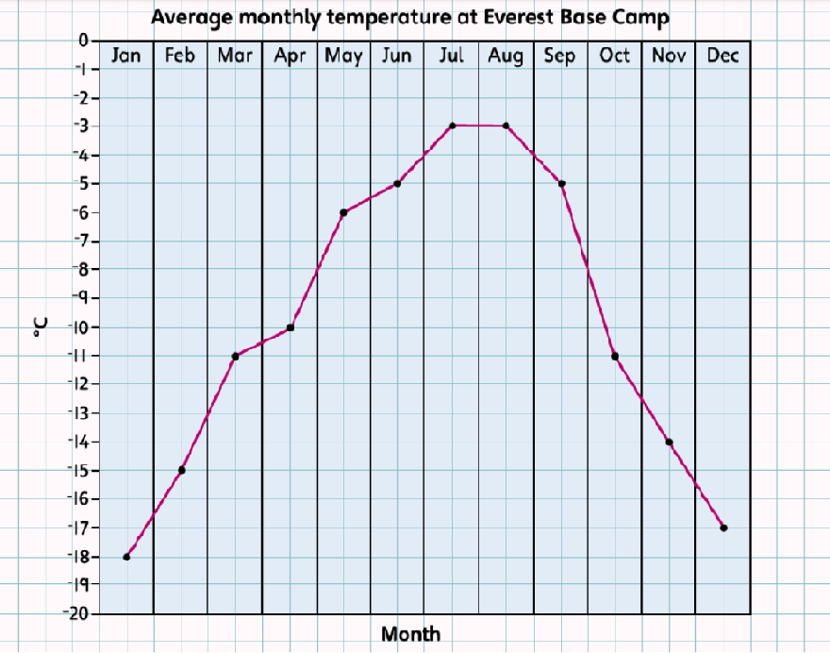

The base camp is at a height of 5364 m, this is why it is so cold.
Mount Everest itself is 8848 m above sea level! Above 4000 m the air has less oxygen in it.
Look at the graph and decide which months are the coldest.

- How cold is it in January and February?
- Which are the warmest months? How cold is it then?
- What is the difference in temperature between the warmest months and the coldest months?

If it is –16°C in January and February and –2°C in July then the difference is 14°C.
The difference between 16 and 2 is 14, so this is the same for –16 and –2.

- How many months of the year is it colder than -10 degrees at Everest Base Camp?

Challenge: If our average monthly temperature in January is around 7°C, what is the difference between that and the average temperature at Everest Base Camp in January?

