Year 2
Half Term Holiday Learning Log
Eisteddfod Craft
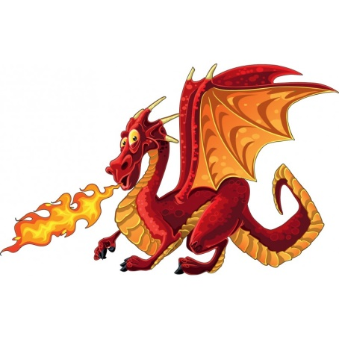
We are looking forward to taking part in the annual St David’s Day celebrations on March 1st. You may wear Welsh costume or Wales sports tops to school on that day.
Year 2 Eisteddfod craft is on the theme of ‘Dragons’.
You can draw, paint, sew, make a model… be creative!
Please make sure that your craft is no bigger than about A4 size.
Bring your dragon into school by Tuesday 27th.
Year 2 will be singing ‘Pump Crocodeil’ – I have put the words on the website for you to practise over the half term holiday.

I have also put some Activelearn activities on your account.
On J2 Blast there are also some spelling and maths games for you to play.

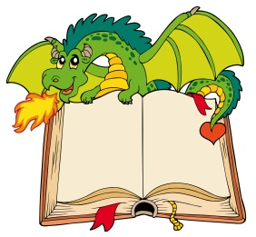
Have a great holiday (remember to keep reading!)

