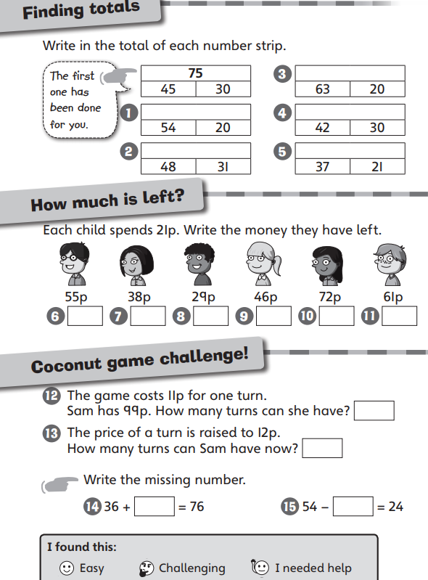
WALT: Add and subtract to/from a 2-digit number

