Term | Autumn1 | Autumn 2 | Spring 1 | Spring 2 | Summer 1 | Summer 2
Topic Name | Inside Out  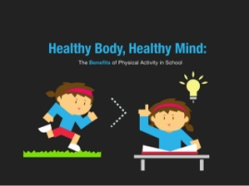 | To infinity and Beyond  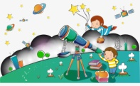 | Wild World  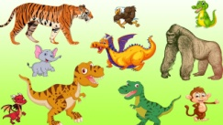 | Once upon a time  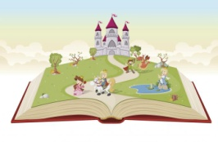 | There is no such thing as a Gruffalo.  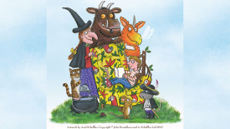 | Sand between my toes  
Book Stimulus | Something Else  My Many Coloured days  Funny Bones  I smell a pickle  Mouse is Mad  Leaf man  Stick Man | Way back Home book Whatever Next book  Toy Story  Space Tortoise  Beegu | Harry and the Bucketful of Dinosaurs  There’s a T-Rex in Town  Dinosaur Stomp | Fairytales  Jack and the beanstalk  Cinderella  Goldilocks and Three bears | Julia Donaldson books | Tiddler  The Lighthouse Keepers Lunch  Billy’s Bucket
Role Play | Baby Clinic  Ysbyty Crist y Brenin | Space Station | Jungle | Fairytale Castle/ Goldilocks Cottgae | Gruffalo Den | Seaside Area/ Beach outside
Trips | Green Meadow Community Farm | Christmas Pantomime |  | Visit Cardiff Castle | Visit Gruffalo Walk | Visit the beach
Below are the Early Years topics for the year. In addition to these planned activities, children will regularly be encouraged to think of some of their own ideas which we will incorporate into our planning (Pupil Voice) Children’s ideas are collected through weekly class discussions and observations. We value all children’s contributions towards our planning, and by allowing children to share their own interests and ideas, they continue to be motivated learners. Alongside the topics below we also follow the Come and See topics for Religious education (overview can be found on the Catholic Life section on the website) We look at a wide range of seasonal and religious festivals throughout the year such as Diwali, Harvest, Christmas, Chinese New Year, Easter, Hanukah.

Inside Out
This term we will be settling in to a new class, we will learn each other’s names, use activities inside and outside of the classroom. We will learn the golden rules. We will be learning all about how we feel on the inside and what our body looks like on the outside. We will also see how our world changes with the approach of autumn.
To infinity and Beyond
We will be exploring the wonders of space and developing our questioning skills. How do you get there? Who has visited there? Who lives there? We will delve into space stories and shoot off into the world of numbers to solve mathematical problems. We will be using different materials to create our own ‘out of this world’ aliens! Counting backwards and forwards ready to blast off into space.
We will follow instructions to make our rockets, work together to complete space jigsaws and puzzles.

Wild World
Let us explore the wild world around us and consider who we share the world with, from the tiny ant to the elephant. The children will discover different habitats using our magnifying glasses on a mini beast hunt. Through artwork and messy play, we will explore different natural textures. Using imaginative picture books, we will use drama to inspire creative writing and storytelling. Natural resources are a great way to investigate numbers and shapes! The children will have many opportunities to use the natural resources when exploring math activities outdoors.
Once upon a time
In this magical half term, the children will be acting out traditional stories, such as ‘Goldilocks and the Three Bears’ and ‘Jack and the Beanstalk’. Through props, painting and printing the children will create their own fairy tale villain. We will help the Jolly Postman to deliver his letters by taking a trip around LLanishen to the post box. Junk modelling and building blocks will allow us to create our own magnificent castles while providing opportunities to become familiar with 3D shapes. In the ‘Fairy-tale Land’, role-play area the children will have a chance to dress up as one of their favourite fairytale characters. We will also be solving number problems to help the detectives discover which characters have been up to no good and explore different coins to buy their magic beans. We will carry out lots of experiments linked to fairytales, who can build the tallest beanstalk, what do plants need to grow? Which house is the strongest and why? We will make pullies to help Rapunzel escape from the tower.

There is no such thing as a Gruffalo
During this topic, we will immerse ourselves into the world of Julia Donaldson books. We will go on Gruffalo hunt in our forest school area, making broomsticks, investigate length and height with the Smartest Giant in Town. After listening to What the ladybird Heard the pupils will learn about the farm. Through the book the FlumFlum tree which only grows on the far away Isle of Blowyernose the pupils will learn about different climates and what different plants need to grow. They will make potions and learn about capacity, full, hall full, empty.
Sand between my toes
The pupils will be exploring the wonders of water. Who lives under the sea? Which objects float or sink and why? We will explore the life of a pirate, use co ordinates to hunt for treasure, dress up as pirates and walk the plank.

