COSTUMES
This is a show full of traditional piratical characters! Here are some suggestion- the photos are only intended as inspiration. Pirates do not need to wear exactly the same costumes as each other and nor do the pirates.

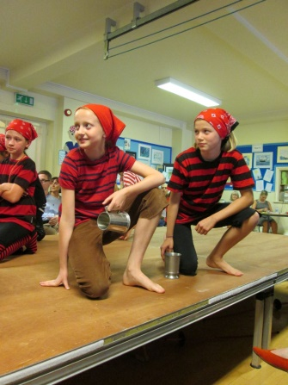

Pirate crew of ‘The Curry Bean’
- Loopy Louie
- Stello
- Broadside
- Calico
- Blunderbuss
- Barnacles
- Bullyrag
- Bilboe
- Bilge
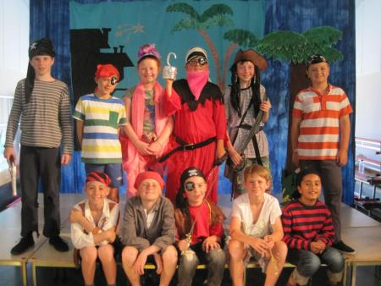
- Squawk

Red/white or black/white striped tops (white t-shirt could have stripes drawn on them)
Knee-length shorts/ dark trousers
bandannas
striped socks/tights
black footwear

Deadeye Dinghy
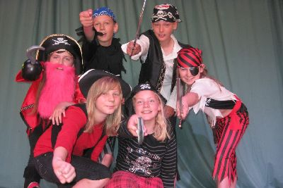
Eyepatch
Red/white or black/white striped top
Knee-length shorts/ dark trousers
bandanna
striped socks
black footwear

Sailor crew of ‘HMS Crunchy Frog’
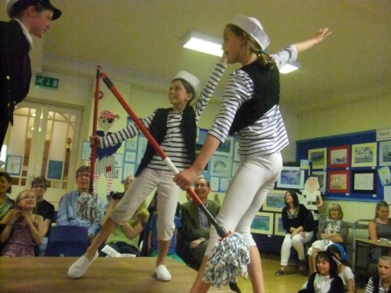
- Scuttle
- Slack
- Lookout Lofty
- Cutthroat Clegg
- Fathom
- Fender
- Fluke
- Gooseneck
- Gibbet
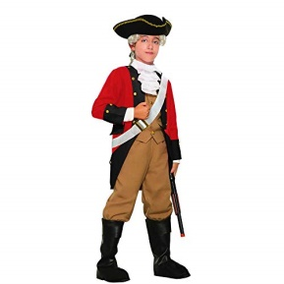
- Grog

Blue/white striped tops
Navy trousers/leggings/shorts
Sailor hats
White/black footwear

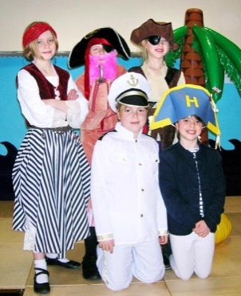
Mr Wally & Mr Pratt (H & S Officers)
White shirt
Black/navy trousers
Plain tie

Redbeard
Pirate outfit, pirate hat and hook (beard provided)

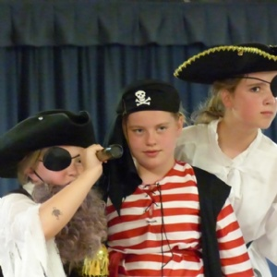

Captain Cod
White shirt with shoulder detail, eg epaulettes
Black/navy trousers
Captain’s hat
Black footwear

Admiral Hornhonker
Fancier than the other sailors! eg. white shirt with coloured sash across body/around waist
Black footwear
Admiral hat
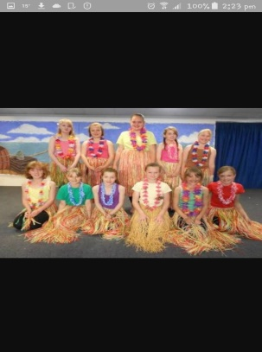

Periwinkle family (Pearl, Liza, Jack)
Pirate flavour, possibly with black/white striped skirts/ tops, trousers and bandannas.

Stanley Periwinkle/Chief Wonga
Colourful t-shirt or Hawaiian shirt
Lei (flower garland)
Knee-length dark trousers/ shorts (could be ragged trousers as he was shipwrecked)
bandanna or pirate hat
striped socks/
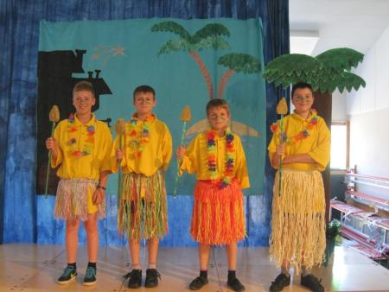

Fiddlesticks the cat
Black long-sleeved top
Black leggings
Black tail/ears

Street Sellers
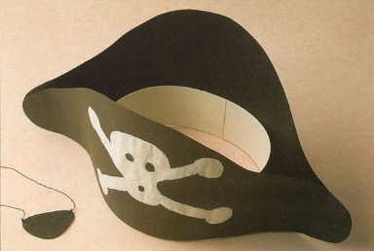
Colourful tops and trousers tucked into long socks / longer skirts
Accessorise with necklaces, headscarves, etc

Lumbagons
Colourful plain t-shirts or Hawaiian shirts
Hawaiian-style grass skirts
Lei (flower garland)

Monkeys
Black tops
Black trousers/leggings/tights
Black tails

Rats
Grey tops
Grey trousers/leggings/tights
Grey tails

