Nursery
Creation and Covenant



Key words
God | Father | Holy Spirit
Creation | Love | World
Stewardship

Key Knowledge
God made our beautiful world and everything in it.   | The sign of the cross:  In the name of that Father, and of the Son and of the Holy Spirit. Amen.  
  God is love. |   What God creates is good.
God wants us to take care of the world.   | 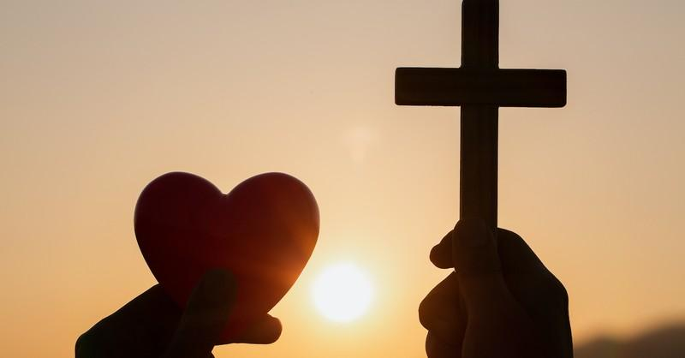  The whole of Creation shows God loves for us.
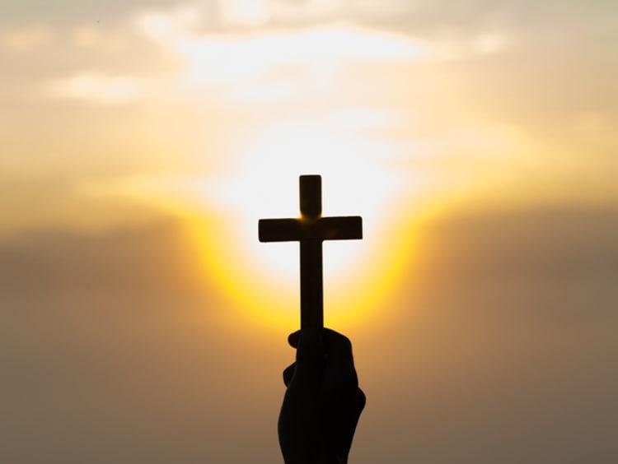  God made each one of us. | 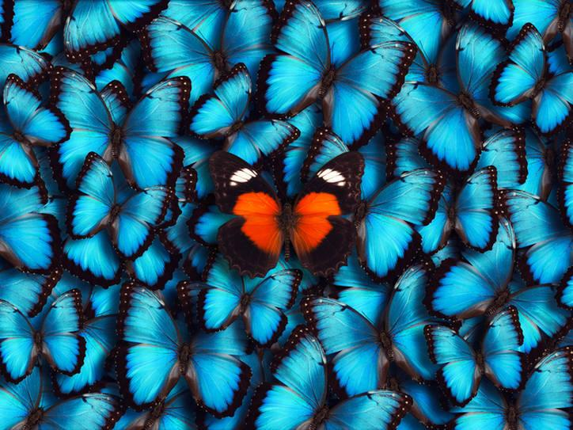  God made each of us as unique person.

