Y2 Creation and Covenant

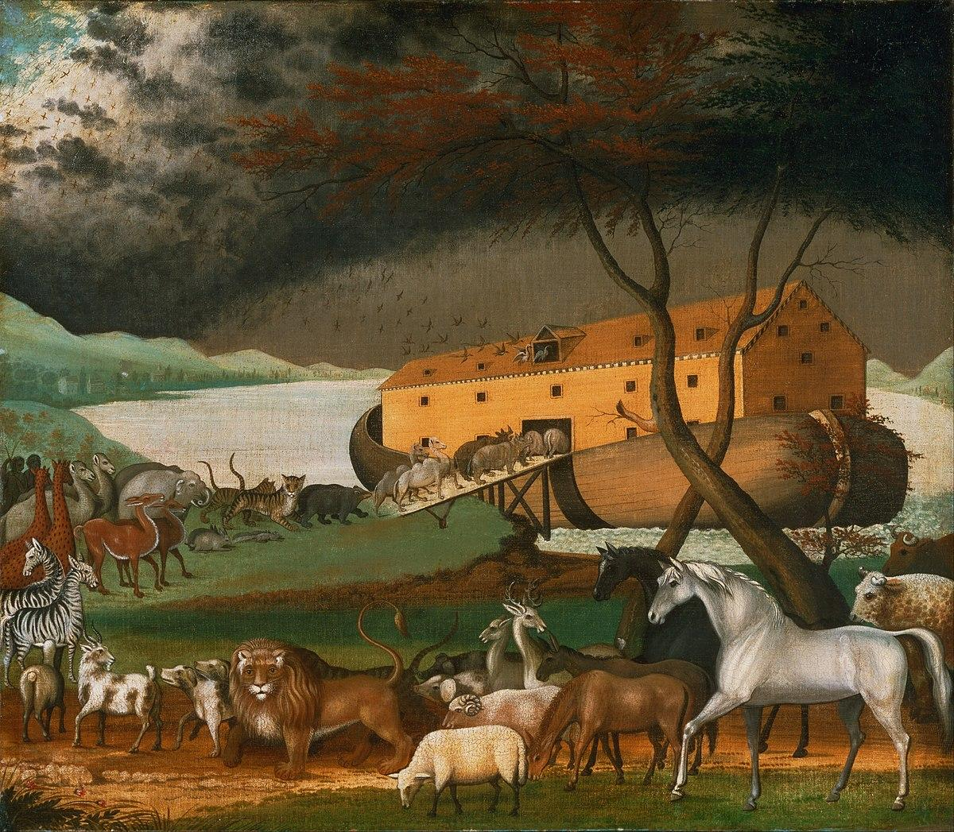

Key words
God | Noah |  | Covenant
Sin | Psalm |  | Sacrament
Baptism | Father |  | Bible
Old Testament |  | New Testament

Key Knowledge
A covenant is a promise.  God made a covenant with Noah to save all living things. | People in the story of Noah turned away from God and chose to act badly. This behaviour is called sin.
Sacraments are living signs of Jesus’ love for all people. | Baptism is the first sacrament which welcomes people into the Christian family.
The Sacrament of Baptism is when a person becomes part of the Christian family and promises to love God. | The Christian Bible is split into two parts called the Old Testament and the New Testament.
Psalms are prayers to praise God. | Psalms can be prayed or sung to praise God.
Showing care for God’s world as part of our care for others is known as stewardship. | Noah is a good example of a steward of the Earth and all living things.

