Year 1 Learning Log
Week Beginning Monday 18th November

Literacy
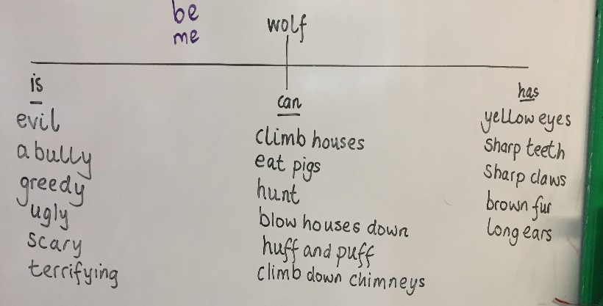
Make a tree map for an animal in a story you have read like we have done for the wolf and the seagull from our stories.

Maths
Look for symmetry in the environment or around your home. Think about some of the shapes and signs we look at.

Daily reading
What digraphs can you spot in the book you are reading? Can you do the actions too?

Class prayer bag:
All classes now have a prayer bag full of ideas and resources for family prayer. The bag will come home with one child a week. Please take the time to reflect ad pray together using what is in the bag. All used resources will be replenished in school.

