Y6 Creation and Covenant

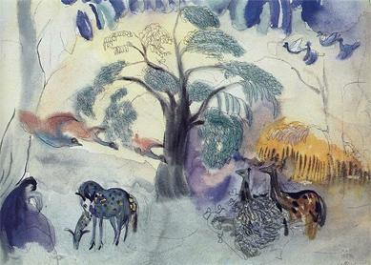

Key words
Creation | Fall | Eden
Evolution | Baptism | Salvation

Key Knowledge
The Genesis account of Creation and Fall is not a literal scientific description, but expresses beliefs about God, the world, and human beings. | In the first account of Creation, humanity is given stewardship of other elements of Creation.  The truth of the second Creation account lies in what it says about human nature and the generosity of God.
The world is in disarray because humans choose to do evil again and again. This is called original sin. | The story of Adam and Eve explains why the world is no longer as good as it was in the beginning.
In Jesus, God restored humanity’s relationship with Him. | Baptism is the first sacrament of the forgiveness of sins. It unites Christians with Jesus Christ, who dies and rises, and strengthens the gifts of the Holy Spirit.
Belief in God as sustainer and source of the universe is compatible with the scientific account of the beginnings of the universe and the theory of evolution. | The Church teaches that the Nicene Creed allows all believers to make a common statement of their faith.
Catholic scientists contribute to the scientific account of the beginnings of the  universe. | Many scientists are Christians and they do not see any conflict between their faith and science.

