Y3 Creation and Covenant

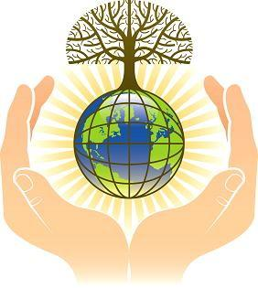

Key words
Genesis | Poetry | Creator
Image and likeness | Dignity | Equality

Key Knowledge
Creation is God’s gift and blessing. | Creation stories in Genesis use symbolism to explain the relationship between God, human beings and the world.  One day is made ‘holy’ in the first account of Creation.
The Church teaches that Creation is the common work of the Holy Spirit. | God is the Creator of the Universe who made everything out of ‘free and unselfish love.’
All human beings are made in God’s image and all people have dignity and are created equal. | Caring for Creation is one of the ways that we care for each other.
The dignity of all human beings is one of the principles of Catholic Social Teaching. | Creation is praised and expressed in the prayer and Liturgy of the Church.
Stewardship is when we show care of God’s world as part of our care for others. | In Laudato Si’, Pope Francis teaches that human beings are called to have a loving relationship with each other, and with the world.

