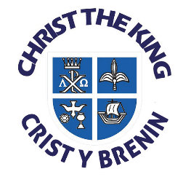Christ the King Catholic Primary School
Everest Avenue, Llanishen, Cardiff, CF14 5AS.
Tel: 029 20754787
www.christthekingcathprm@co.uk
e-mail: christthekingprm@cardiff.gov.uk
Headteacher: Mrs S M Miles
Dear Parents,
Life To The Full RSE Programme – Upper Keystage 2

During the end of the summer term year 5 and 6 pupils normally take part in a series of lessons focusing on sex and relationship development. These lessons include; looking at the changes that happen to girls and boys bodies, menstruation, emotional changes, being careful with what they see online, body image and how babies are made.

As part of the CCHS cluster of schools we use an online teaching platform called ‘Life to the Full’ which is based on ‘A Model Catholic RSE Curriculum’ by the Catholic Education Service. It has been highlighted as a work of good practice by the Department of Education. We have great confidence in this modern, relevant, programme in supporting the growth and development of your child. Life to the full is much more than a traditional series of lessons, it includes a soap opera style video that follows the life of four 11-year olds, as well as a magazine style talk show where issues are discussed in a fun way.

On Friday we sent home an overview of the units covered from nursery all the way through to Year 6. Pupils will be covering the topics highlighted over the next two weeks in particular. If parents have any concerns about content then they can email Mrs Martin – MartinK13@hwbcymru.net or Mrs Welsh – WelshB1@hwbcymru.net

It is also worth noting that in classroom setting girls and boys learn about all of these things together! Boys learn about changes to girls and girls learn about changes to boys.


