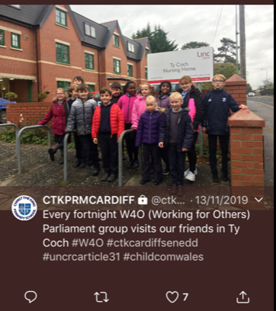
Mission in Action: Learning to Love
Over the past three years, pupils from Christ the King Primary School have made regular visits to Ty Coch Nursing Home in Llanishen.
This initiative began as a response to research from projects in the UK and beyond, which prove that forging intergenerational links has positive benefits for both young and old.
Christ the King School has several ‘Parliament/Senedd’ groups, made up of pupils from across Key Stage 2. Each parliament group meets fortnightly to discuss issues within school and the wider community, with pupils formulating and working on action plans.
The ‘Working for Others’ (W4O) parliament group was established with the aim of putting our school mission of ‘Learning to Love’ into practice in the wider community. Since some of our pupils have connections with Ty Coch Nursing Home, the W4O group were keen to make a visit to perform songs for the home’s residents.
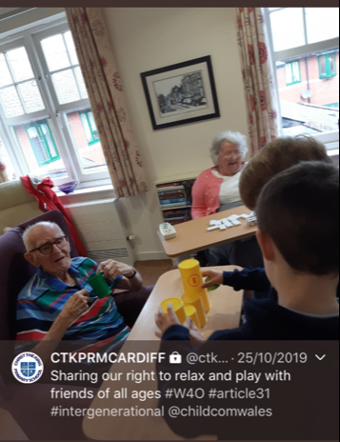
The experience was so positive that we were invited back!
Three years (and three parliament groups) on, our visits to Ty Coch are an established part of school life. Activities vary: we make greetings cards, plant spring bulbs, decorate cakes, play games or sing songs. Last year we were delighted to welcome some of the residents to school to watch a special performance of our Year 6 musical.
Above all, the most enjoyable aspect of our visits to Ty Coch is the chance for the children to make new friends. They enjoy sharing their news and are curious to hear stories of the residents’ experiences of growing up Cardiff in bygone years. The children need to adapt their behaviour to suit the surroundings; in doing so, they learn to be attentive to the needs of others and develop the virtues of compassion for others.
To mark the beginning of this special Year of the Word, we will soon be visiting Ty Coch to share readings and carols from our Carol Service, putting our mission to share love into action this Advent.
Here’s what some of the children had to say about our visits:
At first I was a bit nervous, but now I get excited when it’s time to go there!
I think they are pleased to see us and we like singing songs together
I like keeping them company and it is fun to make things together

