
Lent 2019
This Lent the staff and pupils are Christ the King are supporting the CAFOD theme of GIVE IT UP!
Taking the give it up challenge can be simple:
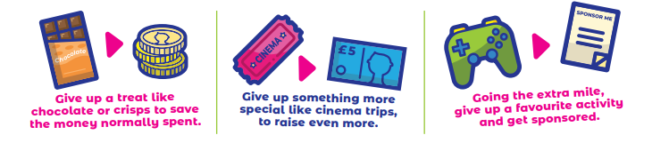
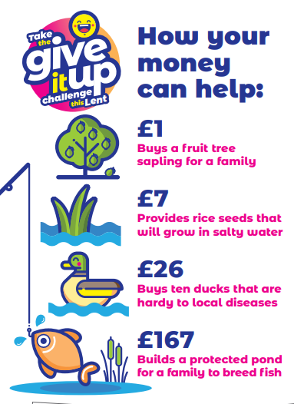
Right of the Child 
Article 24
You have the right to live in a safe, healthy environment with good food and clean drinking water.

Each pupil has been given a fish template; please stick any monies raised to the fish template and return to school by Monday 29th April.
It would be wonderful if each pupil could raise even a small amount, together our school community can help our neighbours around the world.

For I was hungry and you gave me food, thirsty and you gave me drink, a stranger and you welcomed me.
Matthew 25:35

