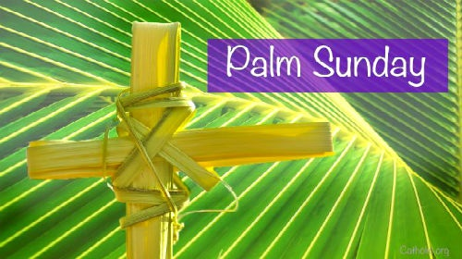
Palm Sunday Liturgy
Dear Parents,
On Monday 8th April, Foundation Phase will be leading our Palm Sunday Liturgy; the liturgy will begin at 10am.
We would like the children to wear bright coloured t-shirts to school on the 8th with their school uniform.
After the liturgy the pupils in Foundation Phase will be selling refreshments that they have made as part of their enterprise activities.
Reception - gingerbread crosses
Year 1 - chocolate nests
Year 2 – Easter biscuits
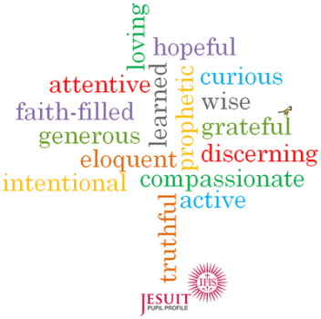
All monies raised will used to promote and implement the different set of virtues that are taught each term.

It would be wonderful if as many parents as possible could attend and support our wonderful pupils during this special season of Lent.
Kind Regards
Foundation Phase Teachers

