
Pirate Pete's

Treasure Map

8

7

6

5

4

3

2

1

 | 
 |  |  | 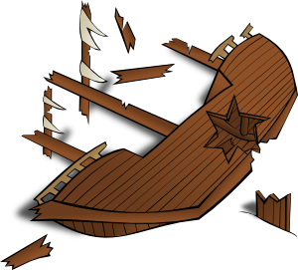 |  |  |  | 
 |  |  |  |  |  | 
 |  |  |  |  | 
1 2 3 4 5 6 7 8 8

Start from the sea, go up to the sky!

Object | Co-ordinates

