
Bore Da,
This week’s storybook is What the ladybird Heard by Julia Donaldson. I will read the story tonight on Seesaw. It would be wonderful if you could use the yellow school book I sent home to complete the learning Log activities. I can’t wait for you to bring the books back to school and show me all your home learning.
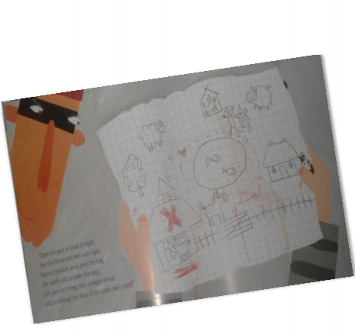
Drawing a map
In the story the burglars try to follow a map of the farm to steal the prize cow.
- Design your own farmyard and label the houses of all the animals. How many pigs live in your sty? How many ducks are in the pond?
- Add directions to your map, e.g. turn left for the pig sty etc.
- Now you are great at making maps, draw a map/plan of your daily walk. Or a map of your garden.
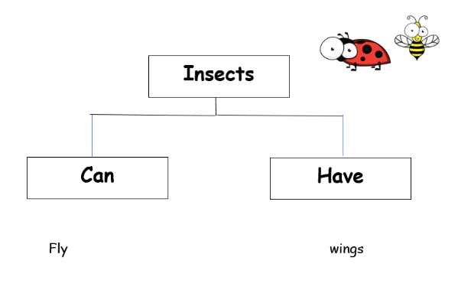
Literacy
- Complete the tree map about insects. Think of as many different insects as possible. What can they do? What do they look like? how many legs do they have?
- I have attached cvc words to sound out and match to the rhyming words.
- Matching the sounds to the animals.
- Instruction sheet activity to complete.

Numeracy
Work out the teen numbers for the different ants.
Remember to log onto these websites to also support home learning.
whiterosemaths.com which has free membership and is a great math’s resource.
oxfordowl.co.uk - lots of literacy-based resources including e-books.

