Bore Da everyone,
Even though it is the Easter holidays I will still be posting the weekly Learning Log and adding activities to Seesaw. These activities are there to support you with your home learning, however it is important that you have time relaxing and having family time during this special and Holy week.


Holy Week Handprint Activities
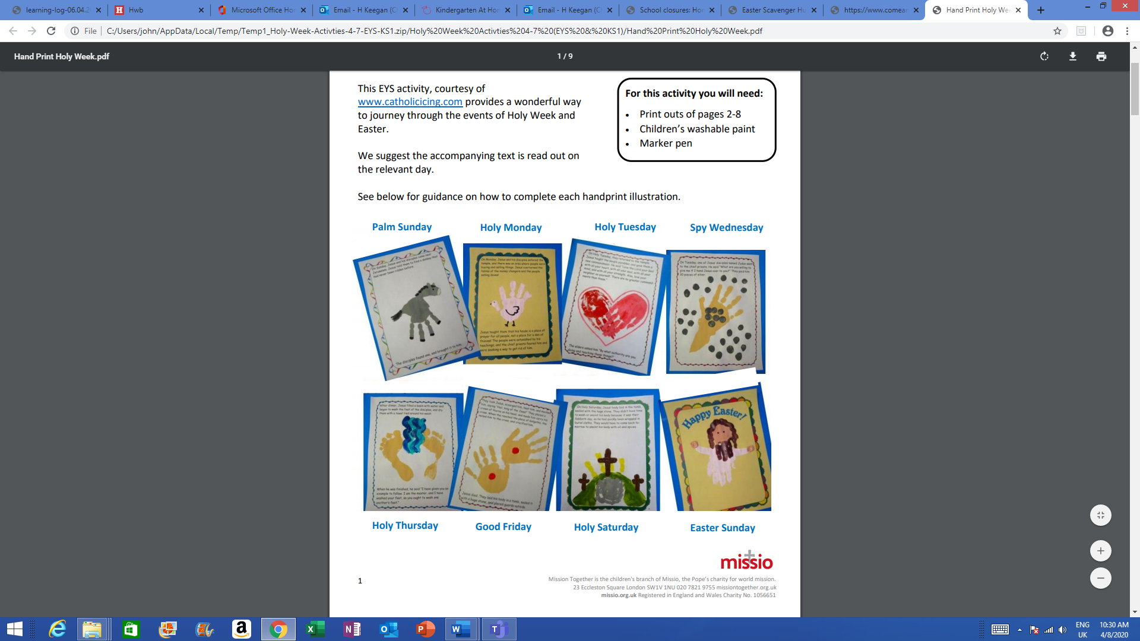
Each day read your child the story from the Bible and use their handprints to create their own picture about the story. The stories have been added to the class page on our school website.
Sorting and matching the Holy week Story
This week is called Holy Week when we remember the last days of Jesus’s life on earth before he died on the cross on Good Friday and rose to new life on Easter Sunday. Cut out the cards and match the pictures with the words to tell the story.
Easter Prayer Card
Make an Easter prayer card to send to someone in your family. You could use the praying hand template, or you may decide to design your own. I will post any photos of pupils with the class chicks to your individual Seesaw accounts incase you want to use this photo instead. Inside the card write your own Easter message. Someone in your family will be delighted to receive a special card from you especially now we cant go and visit family.
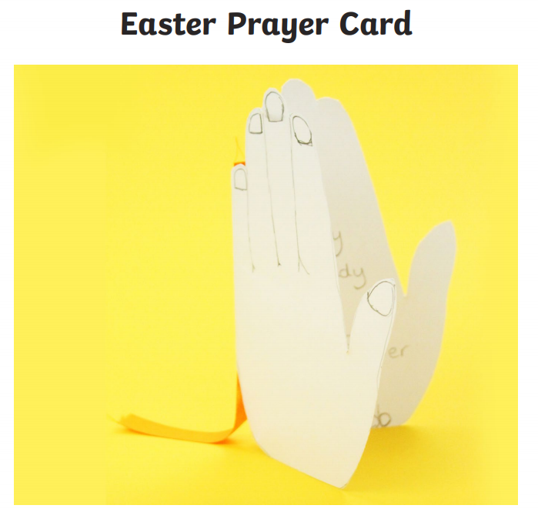
Easter Scavenger Hunt
This Easter Scavenger Hunt can take place around your home. Complete the clues then tick the box when you’ve found the item. You have 30 minutes to find as many as you can.
Friendship Rocks
Be creative, use a stone or pebble (hopefully you have some at home, or you could find them on your daily walk.) Paint a message or ask your parents to help you with some words from the Bible onto your rock. Decorate it and then when you are out on your daily walk, leave the rock for someone to find. Make the rocks as bright as possible so it can be seen. This will make someone smile when they find it and hopefully brighten up their day.
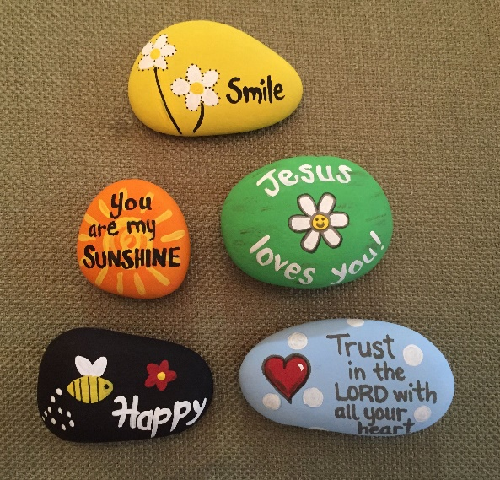
Numeracy - I have added some Easter math’s activities for you to print at home, you can find them on our class page on the school website.
Remember to log in to these websites to also support home learning.
whiterosemaths.com which has free membership and is a great math’s resource.
oxfordowl.co.uk - lots of literacy-based resources including e-books.

Keep learning those tricky words and sharing stories. Look out for my story time video on Seesaw each night x



