Hi everyone,
I hope you are all ok. I am missing you all, thank you for your posts on Seesaw, keep them coming. Its so lovely to see you and to hear your voices. Thank you to everyone who did the learning log activities from last week. I loved your minibeast and lots of you were great with the clock times. Did anyone go on a mini beast hunt in their garden?
Remember to access the class page on our school website go into children then class and click the learning Log icon.
Our story book this week is Jack and the Beanstalk I am going to read the story and post the video on Seesaw tonight. Thanks for tuning in each night.
Numeracy - I have added these activities for you to print at home, you can find them on our class page on the school website.
Write the numbers 1-20 and
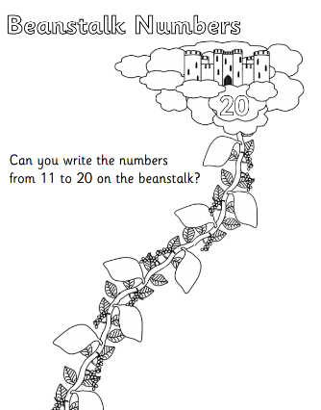
add the missing numbers Patterns
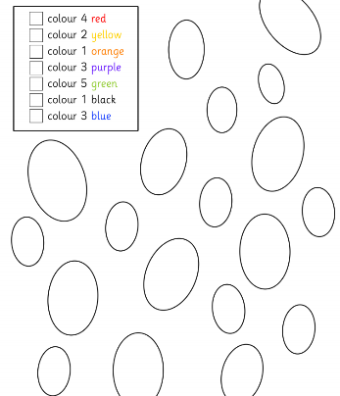

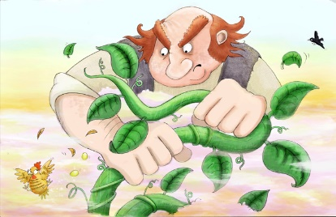

Jack and the Beanstalk Challenges

I have added some challenges for you to complete, you can also find them attached on our class page on the school website.

Making cookies
Use the recipe I have attached to make some giant cookies. Post some pictures on seesaw. I will make some too and post my pictures. Who can make the biggest cookie?
Literacy
Instructions
- You could draw some pictures to show me how you made your cookies, remember to add the words First, next, then finally.
- Use the story sheet to write a sentence about the story. Remember your capital letters and full stops.

Religion
Our topic is growing. I have included a heart template, or you can draw your own. In the heart draw me a picture or write what you think love is. You could draw a picture of someone who shows you love, or how we can love others who are helping us.

Make a circle map ( use the book I send home)to show how during Lent, we can think less about ourselves and more of others and grow in love. How we can do things for others, e.g. pray for them, help them in some way.
These are just some activities for you to use, you don’t have to do all of them. Keep learning those tricky words and sharing stories. Look out for my story time video on Seesaw each night x



