Can you make a really tall beanstalk using the cheerios, and leaves?
Challenge
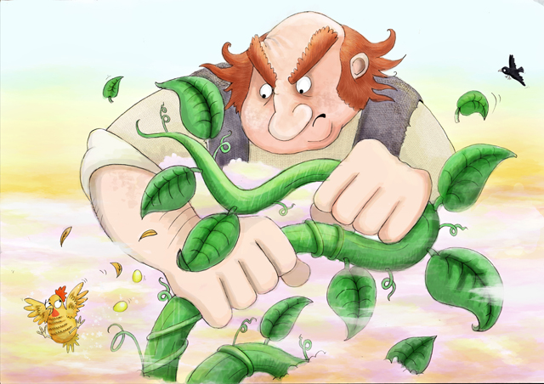
Use the tweezers to add the cheerios to the beanstalk.


