Hi everyone,
I hope you are all ok. I am missing you all, thank you for your posts on Seesaw, keep them coming.

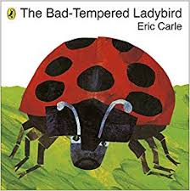
Our story book this week is the Bad-Tempered Ladybird. I am going to read the story and post the video on Seesaw. I will post a message when the video is uploaded.
Numeracy - I have added these activities for you to print at home, you can find them on our class page on the school website.
Ladybird doubles - Use the counters I sent home to double numbers, remember each side needs to be the same, just like the symmetry we worked on in class. Write the number sentences to match the doubles.
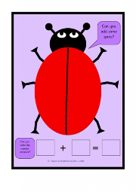
O'clock times – write the clock times and then match them to the correct animal. Remember the long hand always points to the 12 for O’clock.
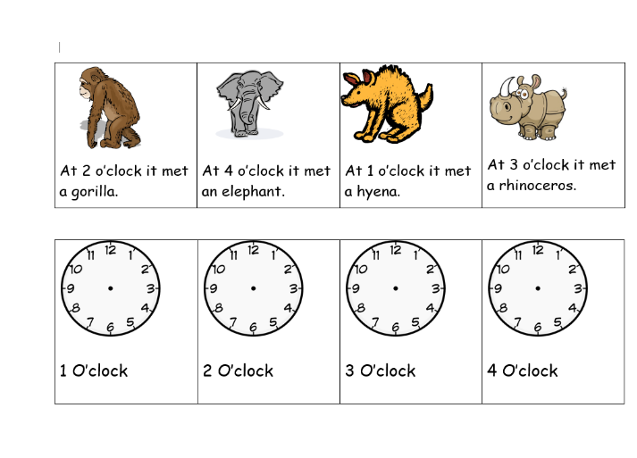

Ordering - Order the clock times starting with the earliest.
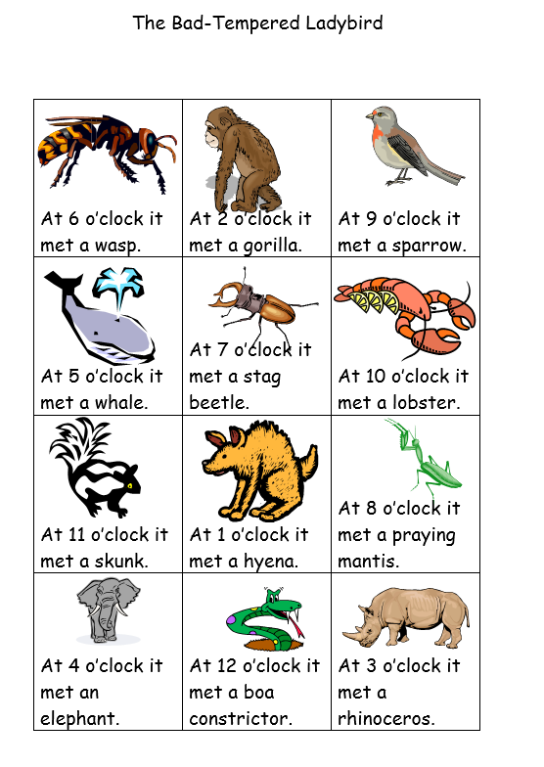
Counting mini beasts - Go on a mini beast hunt in your garden. How many worms, spiders, beetles can you find. Write the number down, use our number rhymes so you start in the correct place. You could even write it in a tally chart, remember we used a tally when we counted our favourite fruit.
| 1
|| 2
|| 3
||||4
Can you remember how we write 5 in a tally?
Expressive Arts
You could make your own mini beast. You could use a pebble/ or recycled material to make a ladybird, butterfly, spider etc.
Take a photo and put it on Seesaw for me. Then you could think of words to describe your wonderful creation.
These are just some activities for you to use, you don’t have to do all of them. Keep learning those tricky words and sharing stories. Look out for my story time video on Seesaw. I will post our next story book and activities on the 1st April x

