Y5 Creation and Covenant

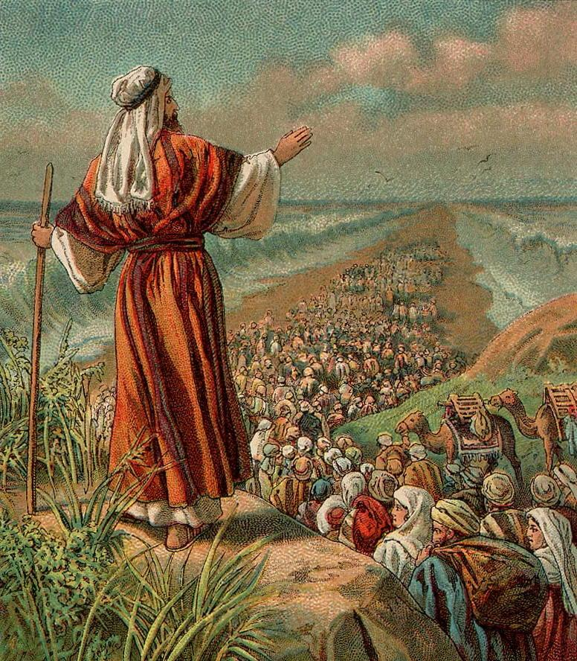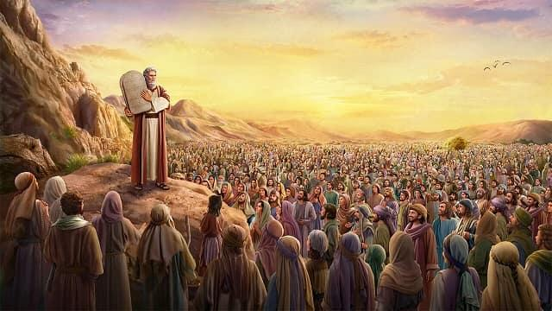

Key words
Covenant | Moses | Exodus
Sinai | Commandments | Virtues
Grace

Key Knowledge
A covenant is a binding agreement between God and human beings, which makes them His people. | God made several covenants throughout history, with Noah, Abraham, Moses and David.
God gives the Ten Commandments to help human beings live good and happy lives. | Jesus teaches that the most important commandments are to love God and to love other people.
Catholic Social Teaching helps us to see that loving our neighbour demands commitment to social change and transformation. | ‘We profoundly belong together and are fundamentally dependent on one another.’
Sin is a deliberate spoiling of our friendship with God and each other. | There are habits which can be developed that help us accomplish what is good. These habits are called ‘virtues’.
Virtues are practical wisdom (prudence), justice, fortitude, and temperance. These are also known as ‘cardinal virtues’. | Through the grace of God we can enjoy the theological virtues of faith, hope and love.

