Bluebirds From Home School Festival
Monday 15th – Friday 19th June

This week we will be joining Cardiff City FC and children throughout Wales for a 5-day festival, incorporating sports- themed literacy, numeracy and PSE activities, together with lots of opportunities for physical activity!
There are 3 packs of activities, designed for different age groups:
- Nursery/Reception
- Years 1/2
- Years 3-6

We would love to see some of the ways you are taking part in the festival!
Please share your learning, photos or videos with us on 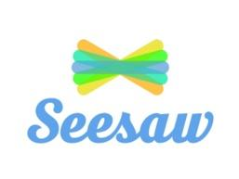
or Twitter @ctkprmcardiff- please remember to tag @CCFC_Foundation
 #CityAsOne

